AutoSaver
Don't waste time anymore!

Thank you for purchasing AutoSaver!

This is really simple asset, you don't need any configuration to make it works, just import it in your project and it will start to work.

You can customize the settings in AutoSaver menu (located in Window > AutoSaver):

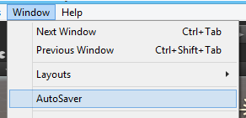
The AutoSaver window contains the major settings you can customize:

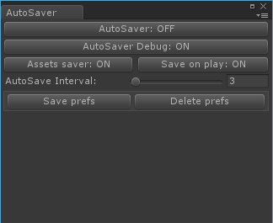
AutoSave: this option allow you to enable/disable AutoSaver
AutoSaver Debug: this option allow you to enable/disable AutoSaver logging
Asset saver: this option allow you to enable/disable assets saving
Save on play: this option allow you to enable/disable saving process when you hit "Play"
AutoSave Interval: this option allow you to choose how many minutes AutoSaver will wait before it will save your scene and assets again
Save prefs/Delete prefs: save and delete your preferences about AutoSaver

AutoSaver is already tested, but bugs can always find a way to annoy you. Feel free to contact me (and nag me to death ;]), I will solve your problem!

Email: m4nu.91@gmail.com
Skype: manhunterita
Twitter: @MHLabSoftware

Thank you again! :)

